# Ticket Booking System - Function Specification

1. Multi-role login system for Admin, Acl’s, and Users.

2. Dynamic adding of horizontal and vertical lines to distribute the seating section-based walk ways.



3. There is dynamic Rows updates for VIP/General as well as the price 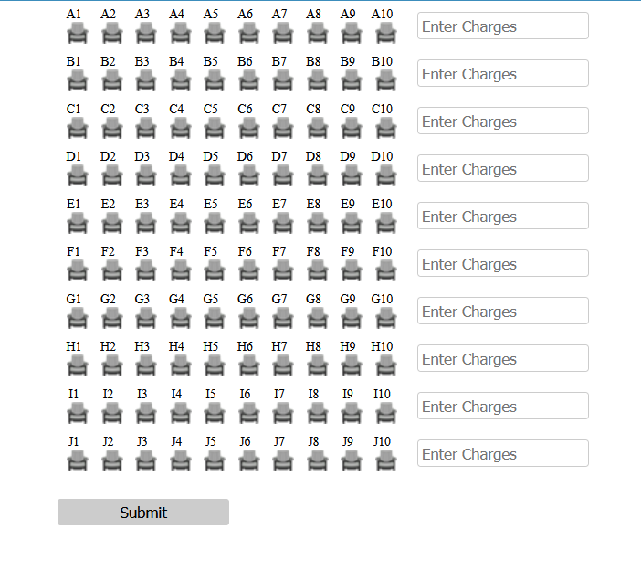

4. Secure payment gateway integration for safe online transactions.

5. QR Code scanning from wall paper, online e-broacher, email notification link

6. Only Temple Administrator Group base Acl’s with Admin rights to buy ticket in-person with cash option

7. Email confirmation along with ticket QR code for each reservation that attendees can scan upon entry to confirm their tickets.

8. Payment processing system will be stripe and test API will be given as we reached to this stage.

How we need to integrate with online payment processing systems with % processing charges (Processing charges should be configurable as per the event)